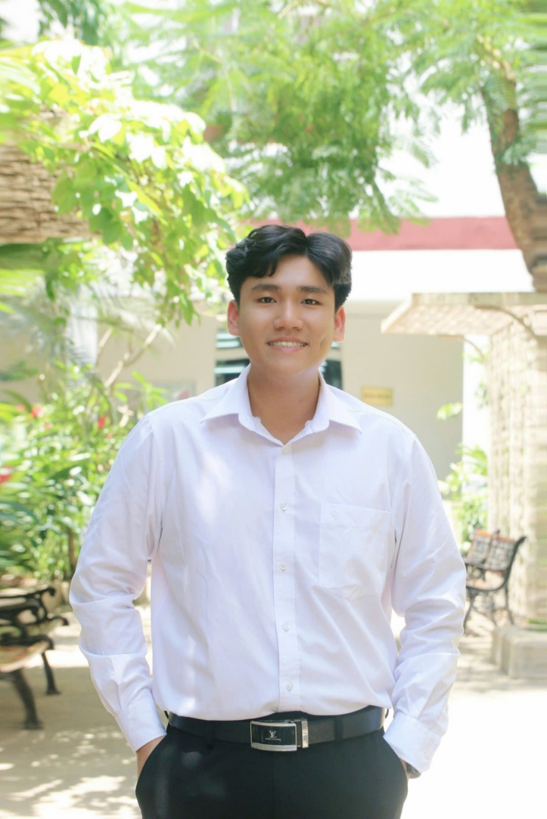
Thuan Kinh Quang Nguyen, M.Eng.
RESEARCH & TEACHING ASSISTANT
Expert Association: IU-VNU HCMC
Expert in Joint Radar-Communication Systems, Integrated Sensing and Communication, Signal Processing, Wireless Communications, and Machine Learning. Thuan’s work focuses on developing reliable and intelligent ISAC frameworks through signal processing, machine learning, and communication system optimization.

Biography
THUAN KINH QUANG NGUYEN was born in Ho Chi Minh City, Vietnam, in 2002. He received the B.Eng. and M.Eng. degrees in Electronics and Telecommunications Engineering from the School of Electrical Engineering, International University - Vietnam National University, Ho Chi Minh City (IU-VNUHCM), in 2025 and 2026, respectively.
He is currently serving as a Research and Teaching Assistant with the School of Electrical Engineering, IU-VNUHCM, where he contributes to research projects and supports academic activities in wireless communications and signal processing. His research interests include joint radar and communication (JRC) systems, integrated sensing and communication (ISAC) systems, signal processing, wireless communications, machine learning, and information theory.

ORCID: https://orcid.org/0009-0004-8139-7077
LinkedIn: https://www.linkedin.com/in/ethan-thuan-kinh-quang-nguyen/
Google Scholar: https://scholar.google.com/citations?hl=vi&user=nMwVY8gAAAAJ

Contact:
Email: nkqthuan@gmail.com
Phone: (+84) 978410829

